**GUDLAVALLERU ENGINEERING COLLEGE**



**ELECTRONICS AND COMMUNICATION ENGINEERING**

**PROJECT NAME : SMART OFFICES**

SUBMITTED BY : A03 BATCH

B.RAJYALAKSHMI(18481A0409)

B. NAGA LAKSHMI PRASANNA(18481A0411)

B. LAKSHMI YESWANTH(18481A0413)

B.MUKUNDA PRIYA(18481A0416)

B.RAVINDRA(18481A0417)

**INDEX**

**TITLE PAGE NO**

1. Introduction 3

1.1 Overview 3

1.2 Purpose 3

2. Literature Survey 4

2.1 Existing Problem 4

2.2 Proposed Solution 4

3. Theoretical Analysis 5

3.1 Block Diagram 5

4. Experimental Investigations 6

5. Flowchart 9

6. Result 9

7. Advantages & Disadvantages 11

8. Applications 11

9. Conclusion 12

10. Future Scope 12

11. Bibilography 13

12. Appendix 13

12.1 Source Code 13

12.2 UI Output Screenshot 14

**1. INTRODUCTION**

**1.1 Overview:**

Now a days IOT is a trending technology by using chat bot we can create many applications like creating a chat bot for taking orders in the restaurant, and we can control a personalized assistant, and also we can create chat bot for apps like whatsapp , facebook etc.

We can also create the chat bot for booking the meeting rooms in office as it is a feature of smart office by using voice based commands we can book the meeting rooms at any instant of time. And also we can control the office appliances like lights and fans etc. It is somewhat similar to the smart home. The only difference is in smart home we can only control the home appliances where as in smart office we can appliances and we can book the meeting rooms. We will use chat bot along node red to book the meeting rooms .For controlling the appliances we will python code along with node red and web ui.

**1.2 Purpose:**

The main purpose of creating the smart office is to create a comfortable and safe working environment that encourages people to collaborate and be productive. By using IOT technology we can achieve this .As the technology is increasing day by day, it makes the life simpler and saves the time. Like this smart office creates the environment in which employees can book the meeting rooms at any instant of time. So their time will be saved so they can utilize this time in completing their projects quickly. It is profitable to both employees and company. And also controlling the appliances through voice commands instead of going near to the switch boards. By controlling appliances through the voice commands we can avoid contact to shocks.

**2. LITERATURE SURVEY**

**2.1 Existing Problem:**

In conventional office there was no technology used to make it as smart. It has some problems like they have to book the meeting rooms one day before the meeting .And they have to disccuss about it. It requires paper documents for writing the meeting schedule. Here some of the time will be wasted. For switch on and off the lights and fan we have to go near the switch board. If it is far it takes time to go. Some times the switches will not work .In order to make them work we have to spent money. Overcoming the above problems we can use IOT technology. By using voice based commands we can book the meeting rooms and also we can control the appliances.

**2.2 Proposed Solution:**

For the solution of conventional office in this project we proposed smart office .It also eliminates the use of papers .We can also book the meeting rooms within minutes. So by introducing the smart office we can also overcome time issues.

The main aim of the project is to design a smart office using the concept of internet of things for booking the slots based on voice based, the voice commands will be given by user. The user should enter the timings, department and meeting room to book the slot. By using microphone we can control the office appliances rather than using switches to on and off appliances.

An office space equipped with IoT devices, and thus connected to the internet, is often referred to as a “smart office”. It represents an intelligent ecosystem that relies on a number of connected devices that, in general, monitor, control, and manage various operations and working conditions.

3**. THEORETICAL ANALYSIS**

**3.1 Block Diagram:**

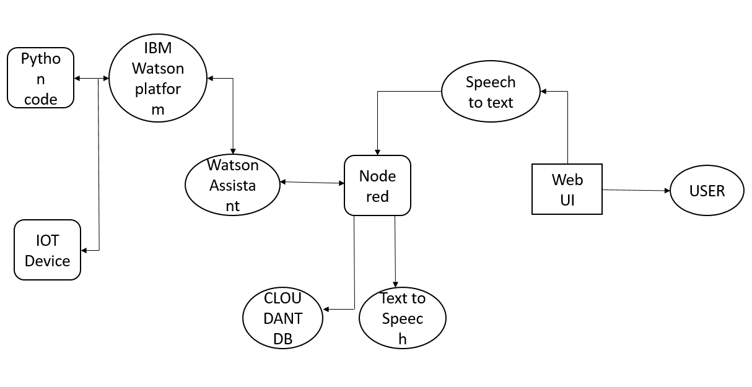

**TOOLS USED:**

* Node-red
* IBM Watson Assistant
* Cloudant DB
* Python IDLE

**4. EXPERIMENTAL INVESTIGATION**

Initially we started our project by creating chat bot in chat bot we written questions asked the user and the answers given by the chat bot to user. We wrote the questions using intents, if the questions have synonyms we used entities, in dialog flow we wrote answers to a corresponding questions.

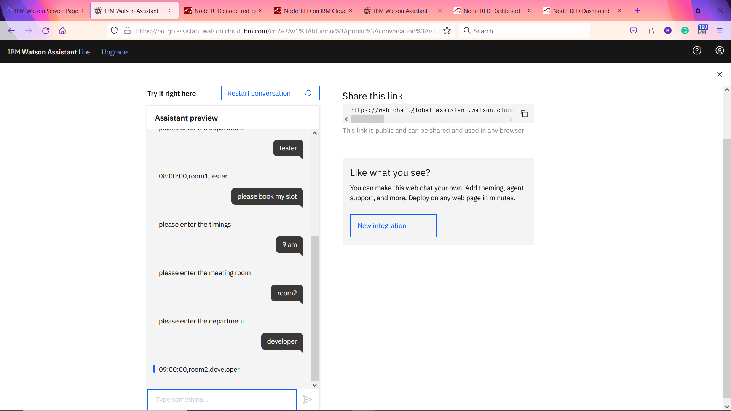

Second step, by using assistant node we have integrated the chat bot to the node red. And giving the commands through microphone. And we stored the output in the cloud date base.

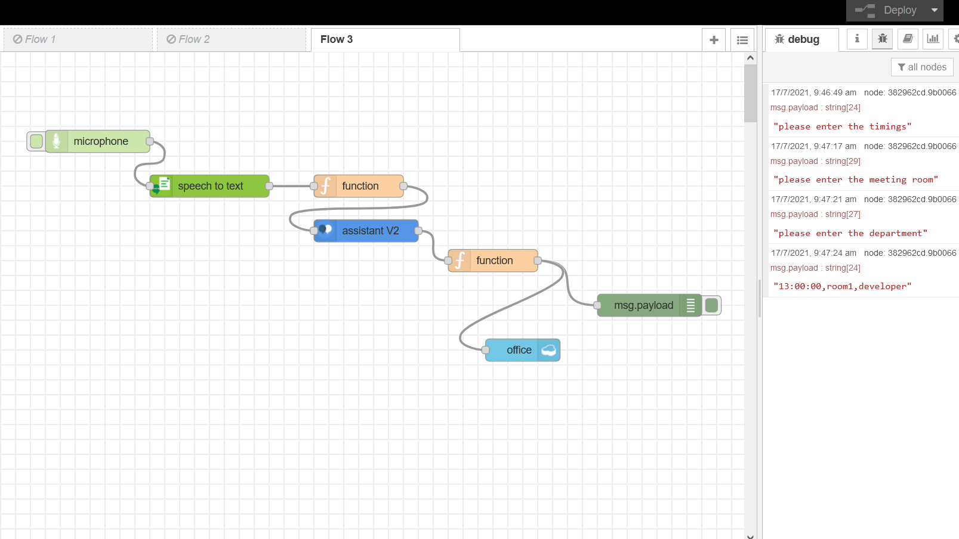

And the next one is to control the appliances by using the microphone from the node red and the output is printed in the python idle.

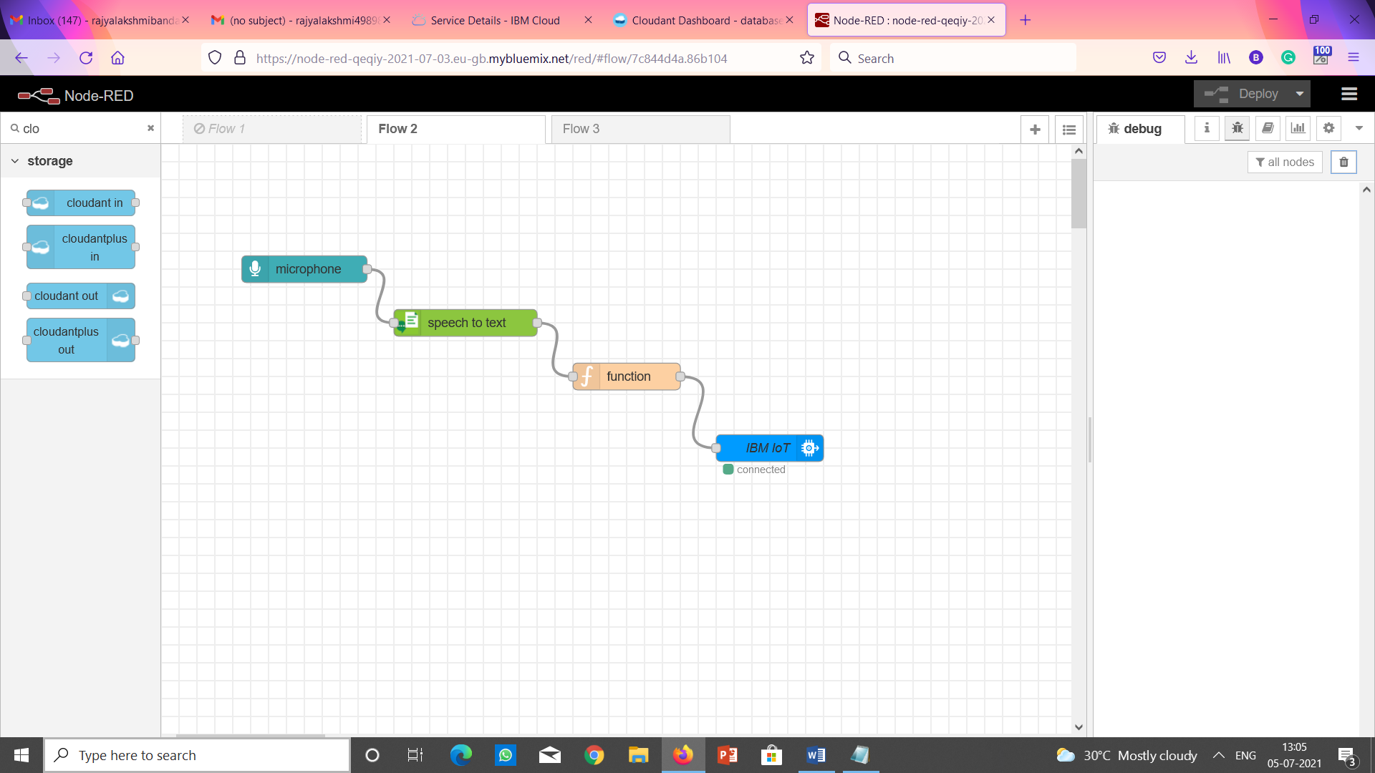

**Output in the python shell:**

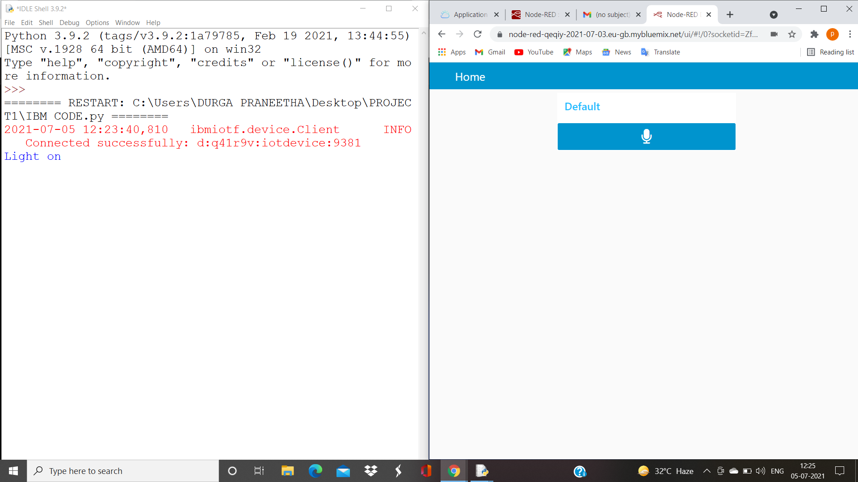

**5. FLOW CHART**

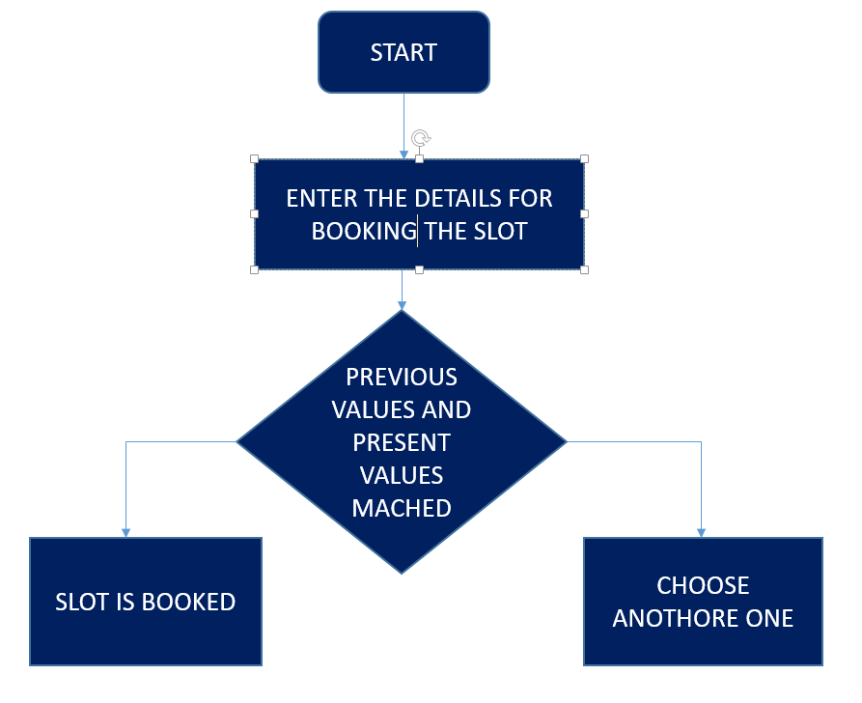

**6. RESULT**

Node red integrated with chat bot using the assistant node taking the voice commands.





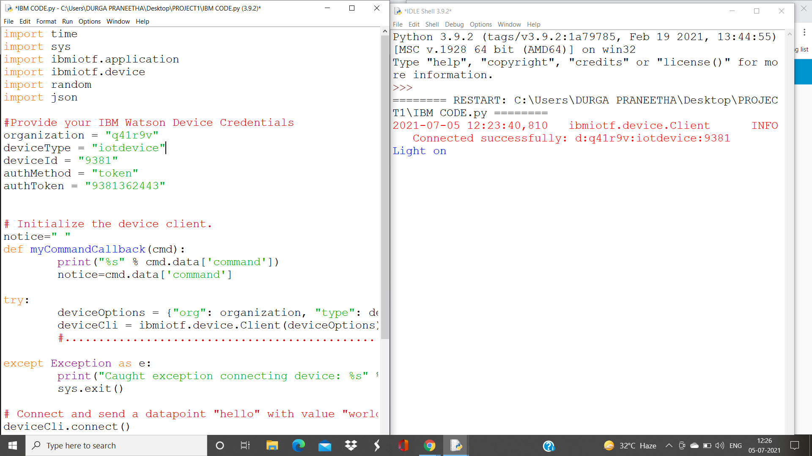

**7. ADVANTAGES AND DISADVANTAGES**

**ADVANTAGES:**

* Time saving
* save energy usage
* Boost productivity
* comfortable working environment

**DISADVANTAGES:**

* If microphone can’t recongise the voice, it can’t work.
* Security from hackers is a big concern in a smart office system.
* It needs the internet connection to control the appliances and to book the meeting rooms.

**8. APPLICATIONS**

* Smart buildings can be implemented by using the smart offices by excluding the feature of booking the slots**.**
* Some of the features of smart offices can be used in shops and in other areas features like switch on and off the lights.

**9. CONCLUSION**

Interviewees consider smart offices to be offices where technology connects users with the internet. Smart offices are seen as “IoT” enabled buildings that make office work easier. Also, these offices are a means of improving sustainability according to the interviewees. Regarding the results of the interviews, it can be stated that for occupiers sustainability seems the most attractive factor of smart property, next to the impact that smart offices have on comfort and satisfaction since they are believed to make office work easier. Regarding sustainability, all occupiers find this an important feature because of the sustainability requirements that are becoming more strict and because it creates a good image towards their customers. Occupiers realize that improvements must be made in the field of sustainability and that technology is the means to reach improved sustainability. An additional finding was that both occupiers and other relevant stakeholders indicated that by using smart features in an office building, it is possible to save various sorts of costs. Regarding comfort and satisfaction, the results indicated that occupiers already experience improved comfort and satisfaction and this improved satisfaction is also expected to increase in the (near) future. Moreover, they claim to receive more value for their money.

**10. FUTURE SCOPE**

As their, is a advancement in technology in day to day life some of the features can implemented in the shops etc.

All the offices are not using this technology .But using this technology we can save energy usage and also we can save the time too. No other other thing on the earth is valuable than time. By using this technology to make the smart offices, employees working in the offices can work in comfortable environment.so, they can concentrate on their work rather than the other activities. So, they can complete the work more faster. Office buildings consume a growing proportion of total energy used in developed economics. A So the forward thinking investor will want to develop buildings that not only use minimial energy but also have the potential to be entirely self-sufficient.

**11.BIBLIOGRAPHY**

* [**https://mobidev.biz/blog/using-iot-for-smart-office-automation**](https://mobidev.biz/blog/using-iot-for-smart-office-automation)
* [**https://www.iotforall.com/iot-smart-office-applications#:~:text=What%20is%20a%20Smart%20Office,various%20operations%20and%20working%20conditions**](https://www.iotforall.com/iot-smart-office-applications#:~:text=What%20is%20a%20Smart%20Office,various%20operations%20and%20working%20conditions)
* [**https://www.softwebsolutions.com/resources/IoT-enabled-smart-office-solution.html**](https://www.softwebsolutions.com/resources/IoT-enabled-smart-office-solution.html)

**12.APPENDIX**

**12.1 Source Code:**

import ibmiotf.application

import ibmiotf.device

import random

import json

import time

#Provide your IBM Watson Device Credentials

organization = "q41r9v"

deviceType = "iotdevice"

deviceId = "9381"

authMethod = "token"

authToken = "9381362443"

# Initialize the device client.

def myCommandCallback(cmd):

print("light on")

print("Command received: %s" % cmd.data['command'])

try:

deviceOptions = {"org": organization, "type": deviceType, "id": deviceId, "auth-method": authMethod, "auth-token": authToken}

deviceCli = ibmiotf.device.Client(deviceOptions)

#..............................................

except Exception as e:

print("Caught exception connecting device: %s" % str(e))

sys.exit()

# Connect and send a datapoint "hello" with value "world" into the cloud as an event of type "greeting" 10 times

deviceCli.connect()

while True:

time.sleep(1)

deviceCli.commandCallback = myCommandCallback

# Disconnect the device and application from the cloud

deviceCli.disconnect()

12.2 UI OUTPUT SCREENSHOT:

In the below picture we can observe the web ui and the python shell. The python shell gets the commands like light on through microphone of web ui according to the commands it displays in the python shell

